STRATA GPO 2026
Conference Keynote
Speaker Script / Teleprompter Notes
CONFIDENTIAL
READING GUIDE
Black text = spoken content
Purple bold = phrases to land hard
Red italic brackets = stage directions
■ BLUE = John Perruccio
■ GREEN = Andrew Meyer
Gray slide header = script content pending

SLIDE INDEX
SLIDE | TITLE | SPEAKER
1 | TITLE | John Perruccio
2 | MISSION | Andrew Meyer
3 | VISION | Andrew Meyer
4 | GROUP PERFORMANCE | Andrew Meyer
5 | GROUP PERFORMANCE (cont.) | Andrew Meyer
6 | GROUP PERFORMANCE (cont.) | John Perruccio
7 | PILLARS OF DIFFERENTIATION | John Perruccio
8 | TECHNOLOGY PILLAR | Andrew Meyer
9 | TECHNOLOGY PRE-2026 | Andrew Meyer
10 | TECHNOLOGY 2026 AND BEYOND | Andrew Meyer
11 | PRIVATE EQUITY PILLAR | [ Pending ]
12 | OPERATIONAL PILLAR | [ Pending ]
13 | WHAT'S NEW: VENDOR OPTIMIZATION | Andrew Meyer
14 | WHAT'S NEW: TECHNOLOGY | Andrew Meyer
15 | COP FLOW | [ Pending ]
16 | PRODUCT SEARCH | Andrew Meyer
17 | PRODUCT SEARCH (cont.) | Andrew Meyer
18 | WHAT'S NEW: EXPANDED TEAM | [ Pending ]
19 | WHAT'S NEW: REBRANDING | [ Pending ]
20 | MVR CHART | [ Pending ]
21 | PBI RANGES CHART | [ Pending ]
22 | PBI REVAMPED | Andrew Meyer
23 | PBI PAYOUT TREND | [ Pending ]
24 | PBI FUND SOURCE MIX | [ Pending ]
25 | VALUE AT TABLES | [ Pending ]
26 | NEXT JOB AT HAND | [ Pending ]
27 | Q&A | John Perruccio

SLIDE 1 of 27
TITLE
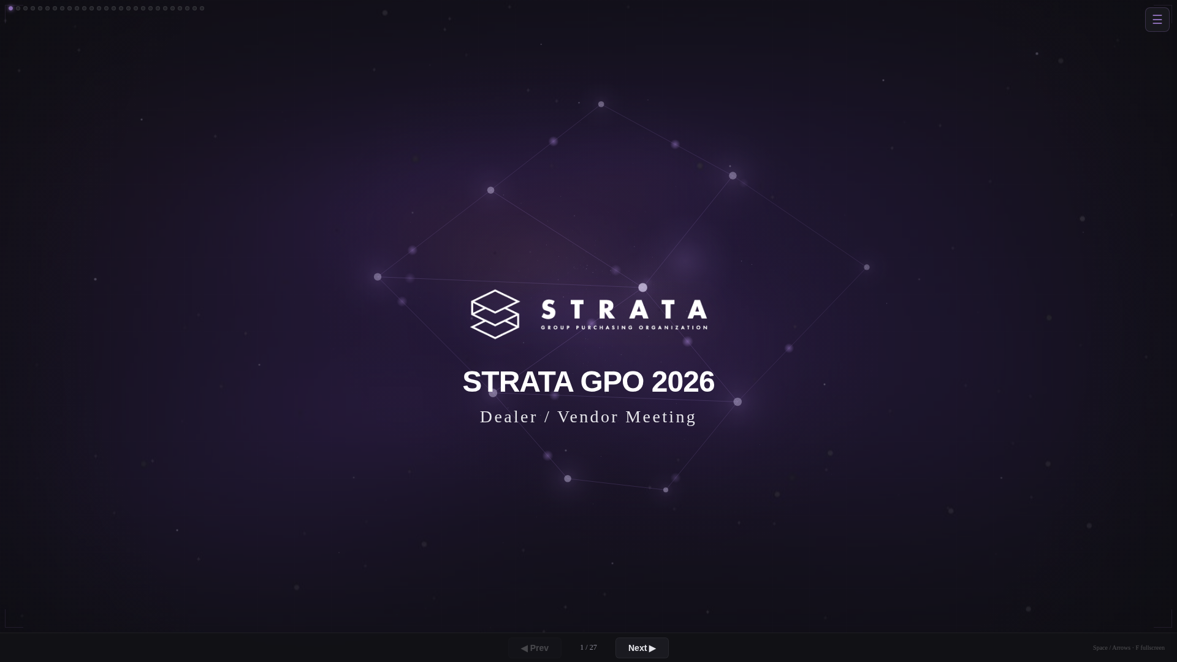
JOHN PERRUCCIO

[ WALK TO PODIUM — TITLE SLIDE ON SCREEN ]
Introduce myself and Andrew and thank you for attending.
Why I came to Strata and why I am excited to be here with all of you!
What should you expect:
• We want this conference to be about several takeaways.
• Walk away with an understanding of what Strata is, the innovation and the vision and how we plan to use technology to better serve your businesses from both perspectives (dealer and supplier).
• Build new relationships to grow your business in a different way.
• We are changing how we do business to help accelerate growth and as you will see, it’s been a hallmark of our past.
We are going to unpack the Past, Present (8 months) and Future of how we see Strata evolving and growing to serve you.
It’s all about being part of the community and contributing to its success.
We have 3 keynote speakers which is a little unusual. It is intentional in that we are trying to make sure that when you leave the conference you are:
• Excited and know where we are going
• Excited about what Strata is building to set you apart
• Understand how the tools and technology can help differentiate you in the market along with your own insight and efforts
• Hear a message through one of our guests that ensures you get involved, be a part, take and give to the community so that you may prosper within it
Let’s get started.

SLIDE 2 of 27
MISSION
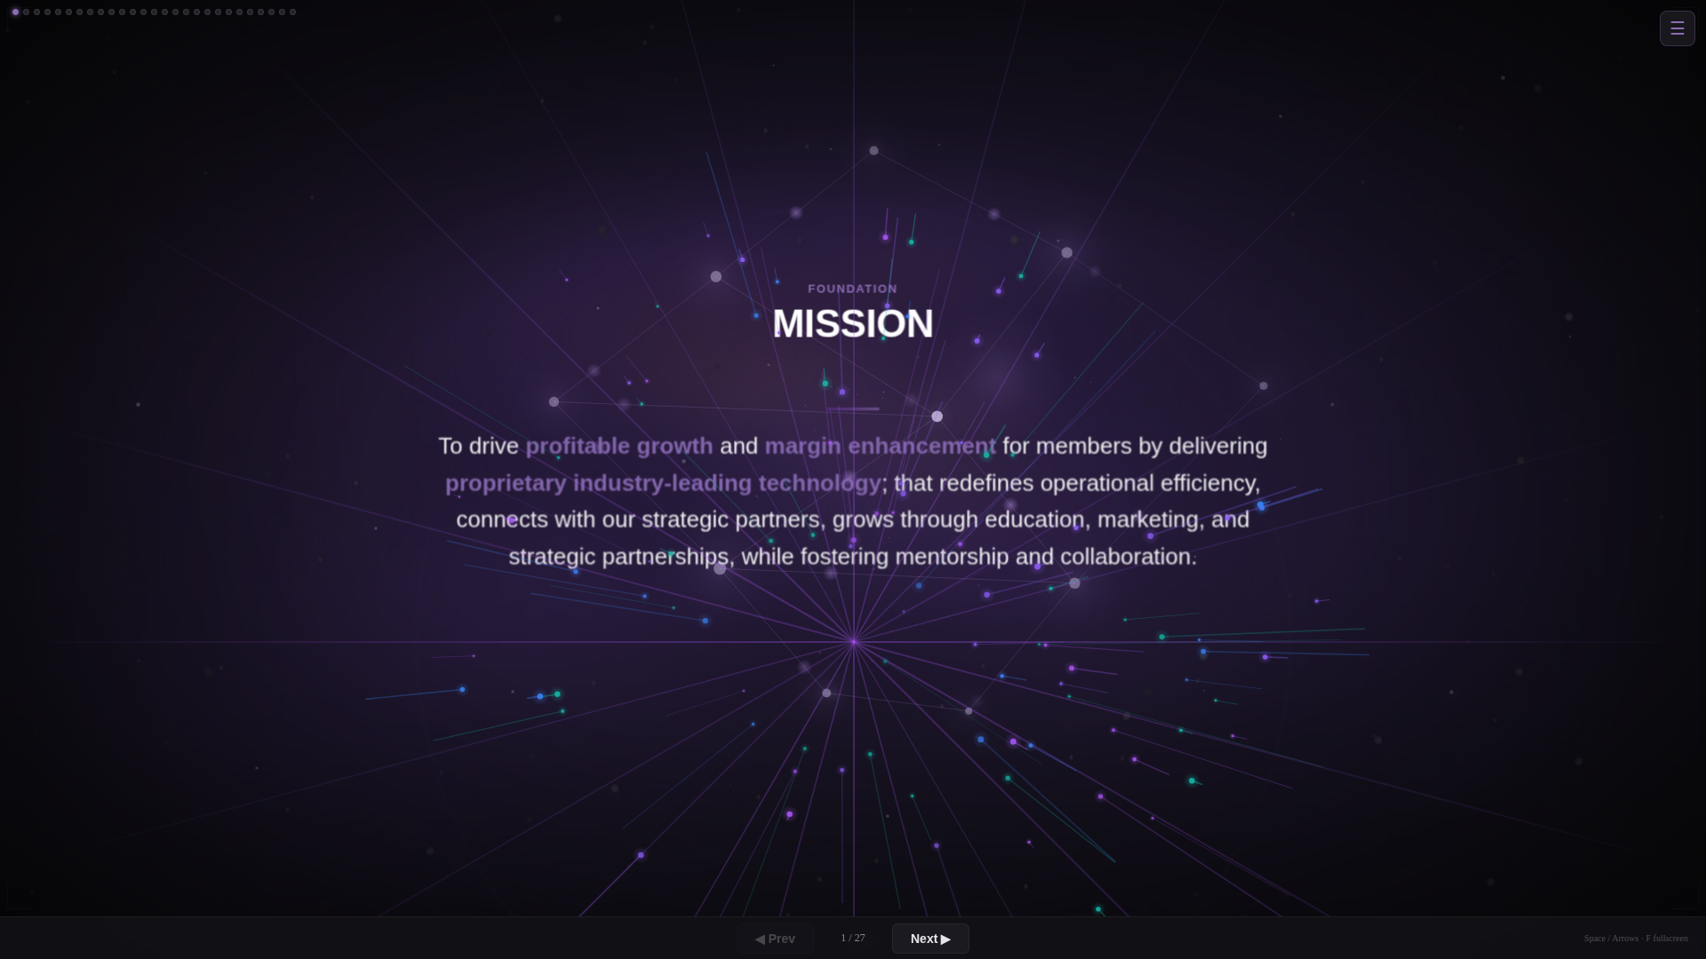
ANDREW MEYER

Before we look forward, let’s ground ourselves in why we’re all here.
Our mission hasn’t changed. Drive profitable growth and margin enhancement for our members. That’s the job.
We do it through proprietary technology we build ourselves, strategic partnerships, education, marketing, mentorship, and collaboration.
Build. Not license. Not outsource. Build.

SLIDE 3 of 27
VISION
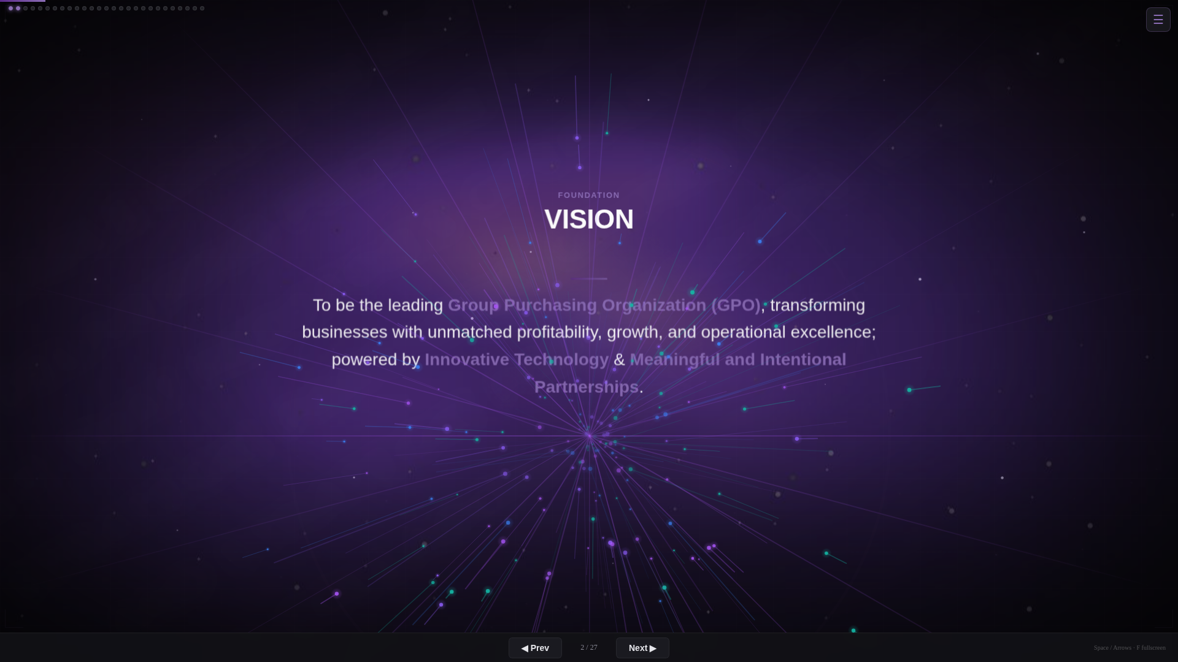
ANDREW MEYER

Here’s where we’re going.
We are building the most innovative, member-focused buying group in this industry.
An organization that empowers dealers, strengthens vendor partnerships, and drives sustained profitable growth through technology, collaboration, and service.
That’s not aspirational. That’s the plan. And we’re executing on it right now.

SLIDE 4 of 27
GROUP PERFORMANCE
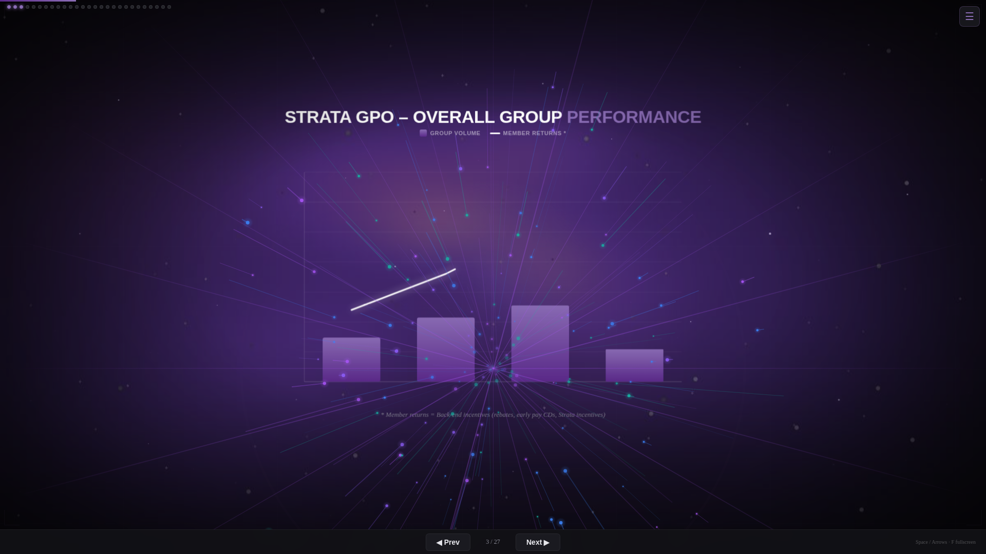
ANDREW MEYER

[ BAR CHART BUILDS IN ]
Alright. Let’s talk performance. This is the part I’ve been looking forward to.
Most of you were in this room last year when we said 2025 was going to be a significant year for Strata.
I’ve been here for 10 years. This company has been in business for 31 years.
And I’m excited to tell you:
2025 was the highest growth in group buying power in our company’s history.
[ PAUSE — LET THAT LAND ]
Okay. So why does that matter to you?
• We’re expected to deliver more annual growth rebates to members in 2025 than ever before.
• It puts us in a position to make critical choices for future expansion. Vendor optimization. Strategic capex investment for your near-term needs and long-term growth.
More buying power means more money flowing back to you. That’s what this is about.

SLIDE 5 of 27
GROUP PERFORMANCE (cont.)
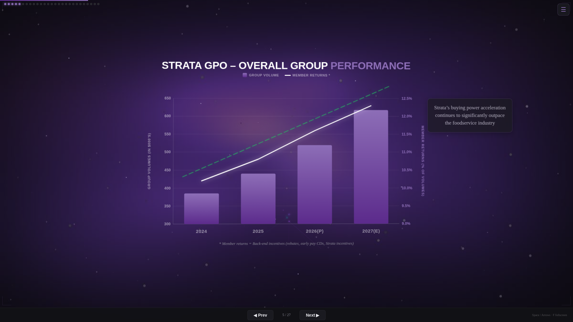
ANDREW MEYER

[ TREND LINE + STATS OVERLAY ]
Looking into 2026 and 2027, our strategic plan continues to expand our collective buying power.
Member returns equals group-driven profit. And that profit is expected to accelerate from this momentum.

SLIDE 6 of 27
GROUP PERFORMANCE (cont.)
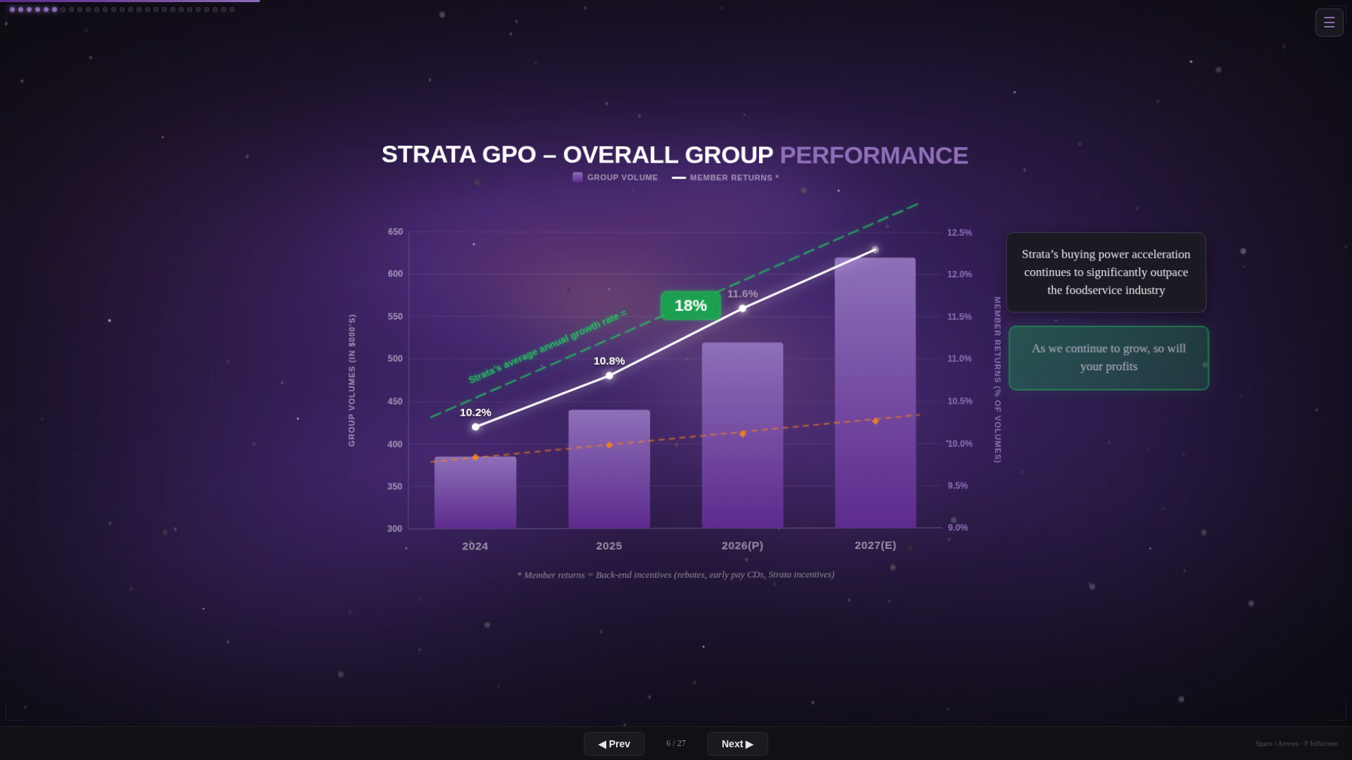
JOHN PERRUCCIO

[ INDUSTRY COMPARISON ]
Now look at this.
Strata: 18% growth. Industry average: 3.5%.
Let me hit that one more time. We’re not just outpacing the industry. We’re on a completely different trajectory.
Think of it like a stock. You don’t buy a stock for the price today. You buy it for where it’s going.
This is a company that’s accelerating. And as we grow, so do your profits.

SLIDE 7 of 27
PILLARS OF DIFFERENTIATION
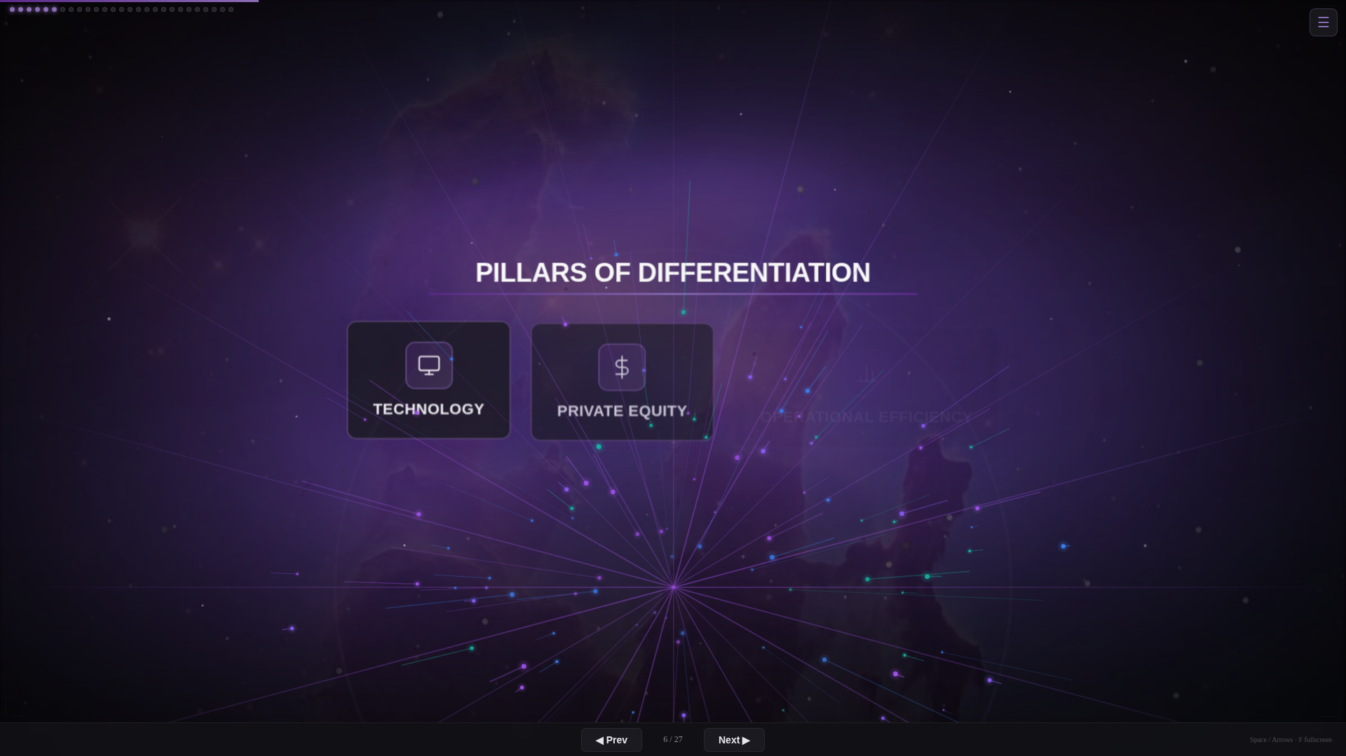
JOHN PERRUCCIO

We want to be able to help dealers of all sizes in this room grow.
• Dealers may elect to use different tools and in different ways. Some may elect to use a platform to enhance their offering to their clients, others may elect to use a platform to help supply their partners.
A significant portion of the tools are usable by everyone in this room on either the Dealer or Supplier side of the equation.

SLIDE 8 of 27
TECHNOLOGY PILLAR
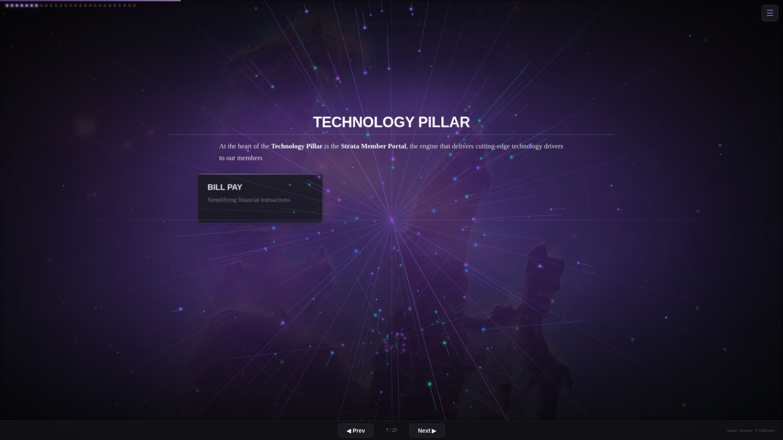
ANDREW MEYER

The member portal is where this comes to life.
Full rebate reconciliation. Back-office extensions. Cash-flow accelerants. Central payment. Reporting and analytics. All in one place.
These aren’t features for the sake of features. Every one of these puts real dollars back in your pocket.

SLIDE 9 of 27
TECHNOLOGY PRE-2026
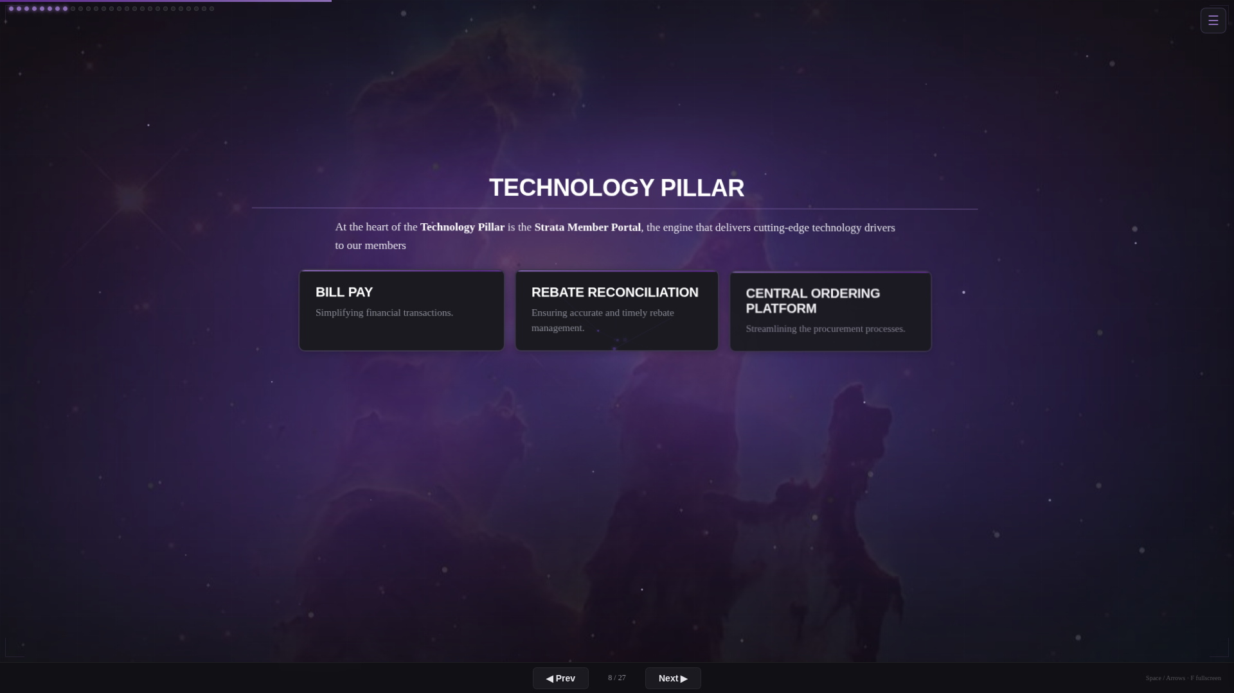
ANDREW MEYER

In 2024, we rebranded into one entity: Strata. And we elevated our technology and data analytics through the member portal.
In 2024 and 2025, we invested over $3 million in technology. 100% of that development spend came from outside vendor partners. Not from your rebates.
Let me say that differently.
Innovation is funded through private investment, not dealer rebates. We build technology for you. We don’t ask you to pay for it.
In 2026, we’re investing another $2 million-plus.
And we’re bringing development capabilities in-house to accelerate. Director of Data Analytics, and possibly more to come.

SLIDE 10 of 27
TECHNOLOGY 2026 AND BEYOND
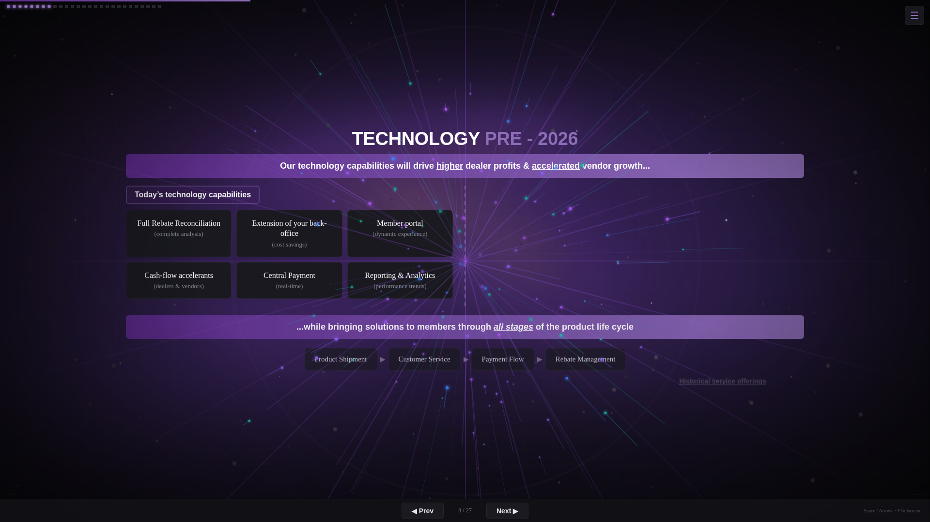
ANDREW MEYER

In 2025 we completed a comprehensive assessment of our tech capabilities. Here’s where we landed.
Reporting and Analytics:
• We will provide training and education so you know exactly how to use these tools.
• Reporting yesterday’s news is important. But providing data insights into your next purchase? That’s critical.
• Line-item detail and product categorization insights will be leveraged for predictive analytics.
Our ultimate goal: make our members more profitable and drive accelerated growth through AI and data analytics. Our near-term roadmap gets us there.
Customer Service:
• A cohesive member service experience, accomplished through AI and tech investments.
• Enhanced training and communication on how to use the tools.
• Portal chat features. Get your questions answered in real time.
• A cohesive data warehouse engine. That’s the foundation for AI and analytics at scale.
• Integration pathways between Strata and your member platforms.
Quick note: in 2025 we introduced a cloud-based ERP system on the back end of our technology. No hiccups. Members were completely unimpacted. That’s the kind of execution we’re talking about.

SLIDE 11 of 27
PRIVATE EQUITY PILLAR
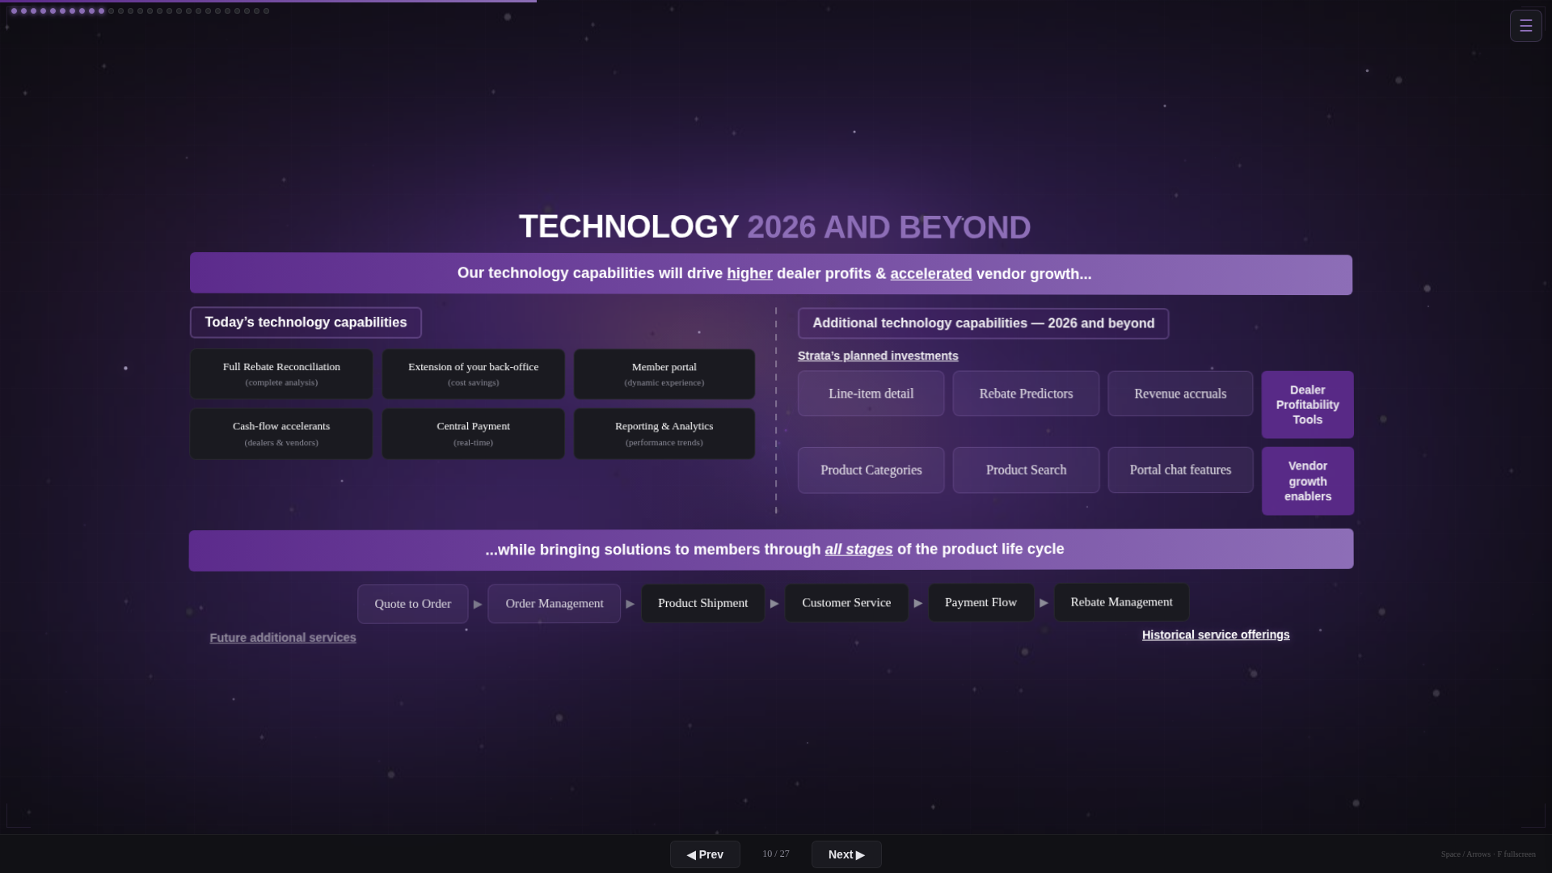

[ Script content to be added ]
Visual / data slide. Speaker notes pending.

SLIDE 12 of 27
OPERATIONAL PILLAR
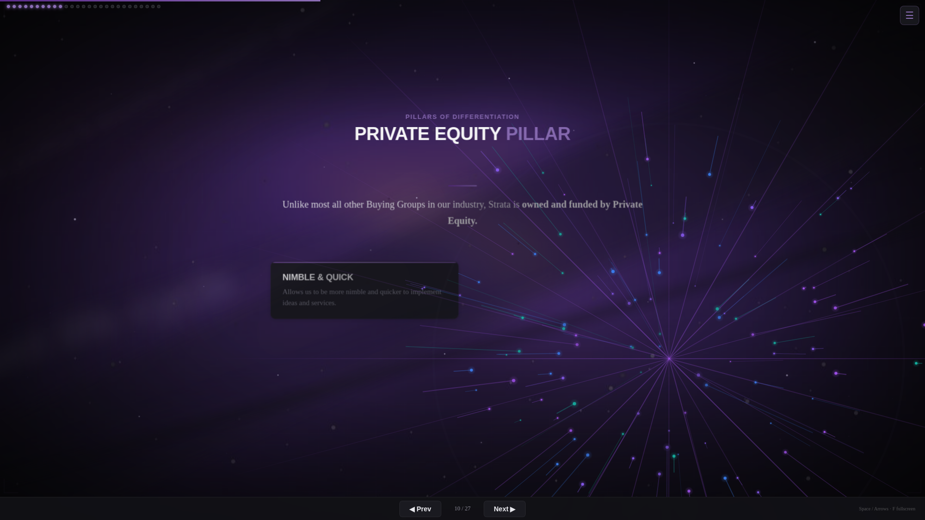

[ Script content to be added ]
Visual / data slide. Speaker notes pending.

SLIDE 13 of 27
WHAT'S NEW: VENDOR OPTIMIZATION
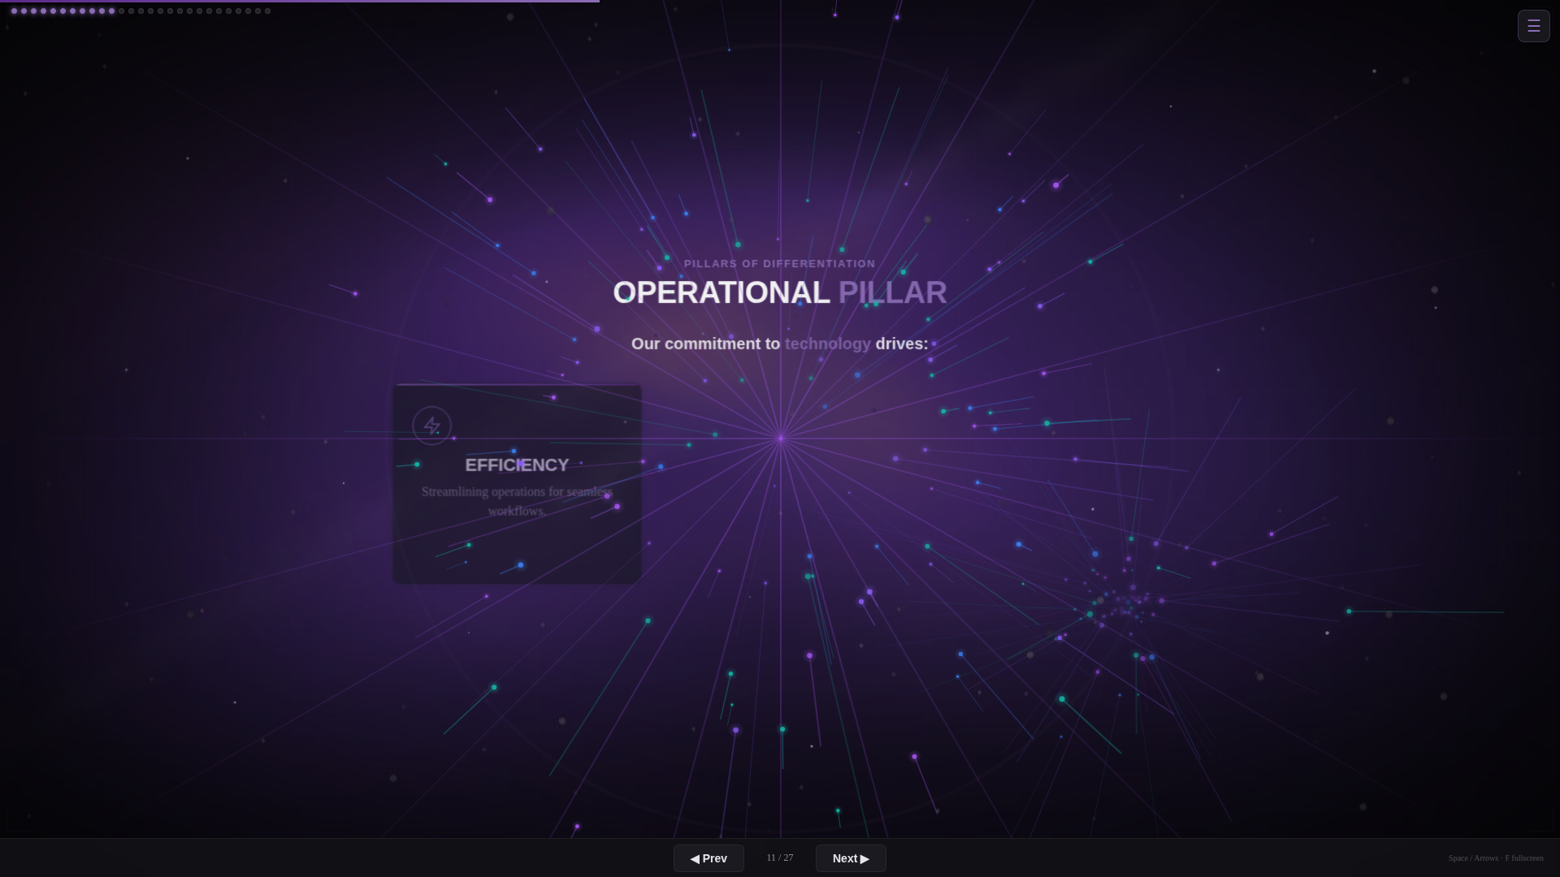
ANDREW MEYER

Quick snapshot of what’s new for members, vendors, and on the technology front.
We’re investing across the board. Not because it’s trendy. Because it’s how you grow.

SLIDE 14 of 27
WHAT'S NEW: TECHNOLOGY
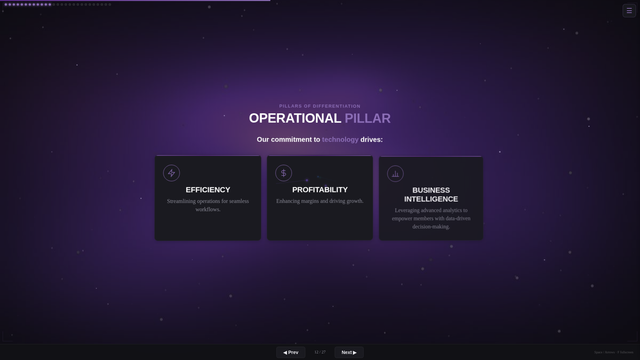
ANDREW MEYER

Quick snapshot of what’s new for members, vendors, and on the technology front.
We’re investing across the board. Not because it’s trendy. Because it’s how you grow.

SLIDE 15 of 27
COP FLOW
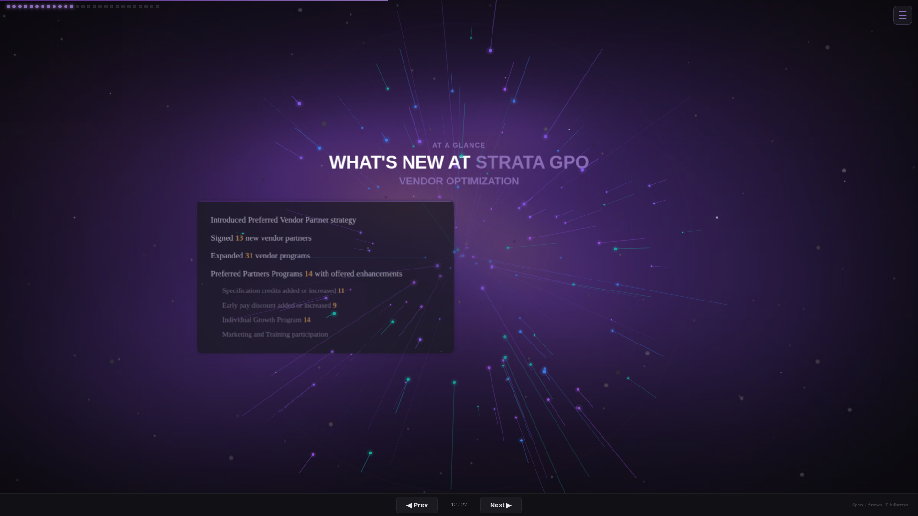

[ Script content to be added ]
Visual / data slide. Speaker notes pending.

SLIDE 16 of 27
PRODUCT SEARCH
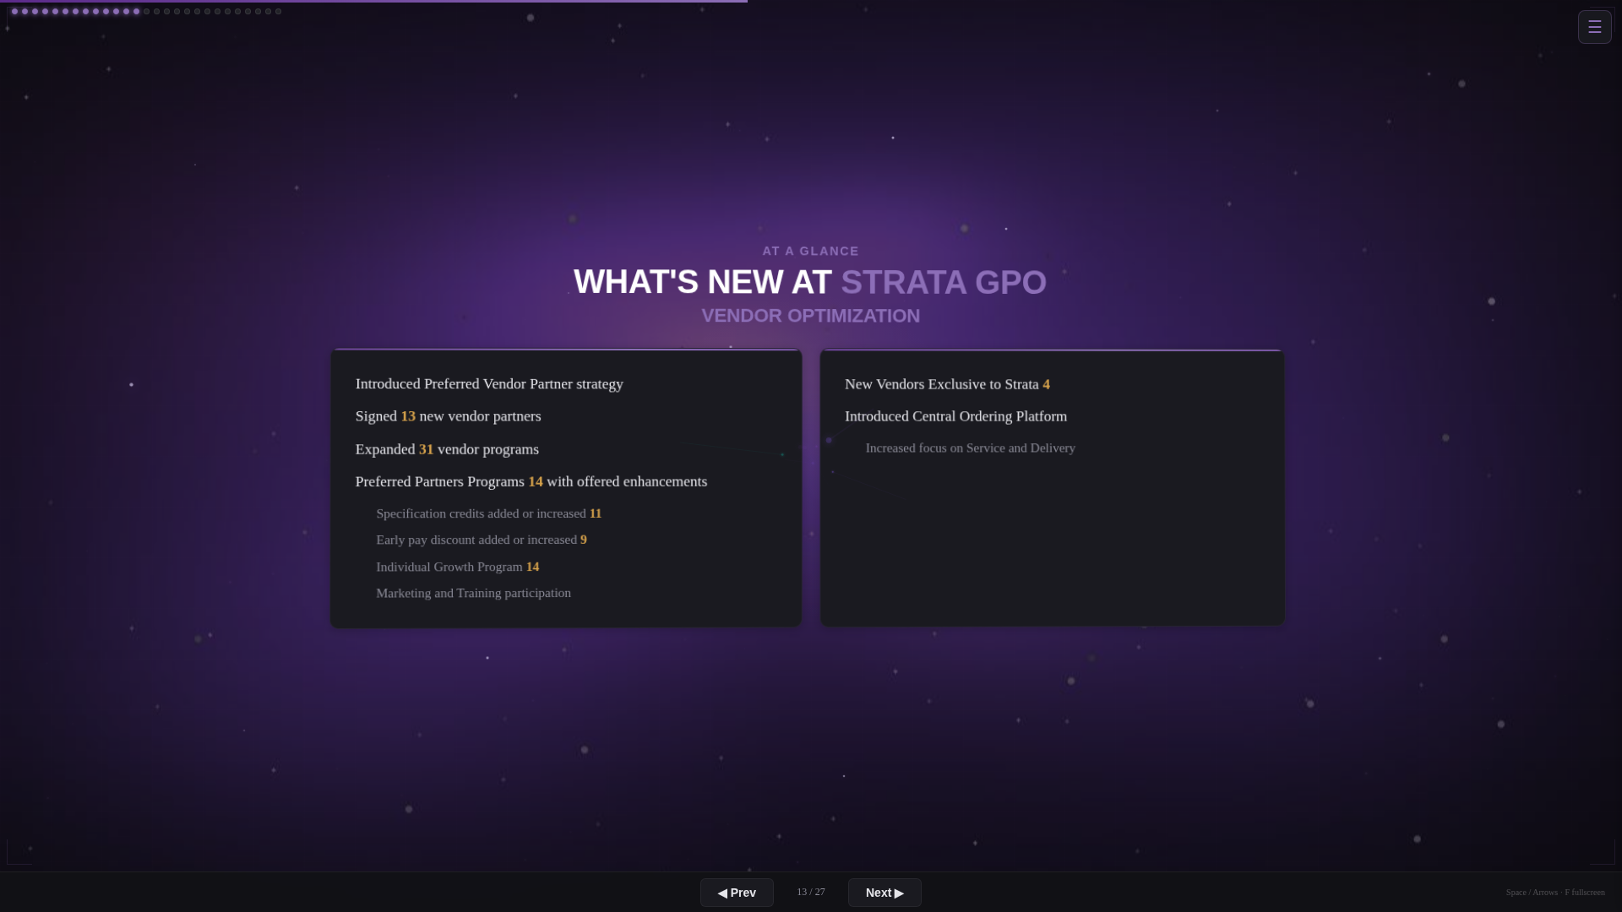
ANDREW MEYER

[ TABLE BUILDS IN ]
Now let me show you something from our Dealer Profitability Tools.
This is Product Search. You search for a product type, and it finds you the best price. Net and Net Net.
Look at Vendor A here.

SLIDE 17 of 27
PRODUCT SEARCH (cont.)
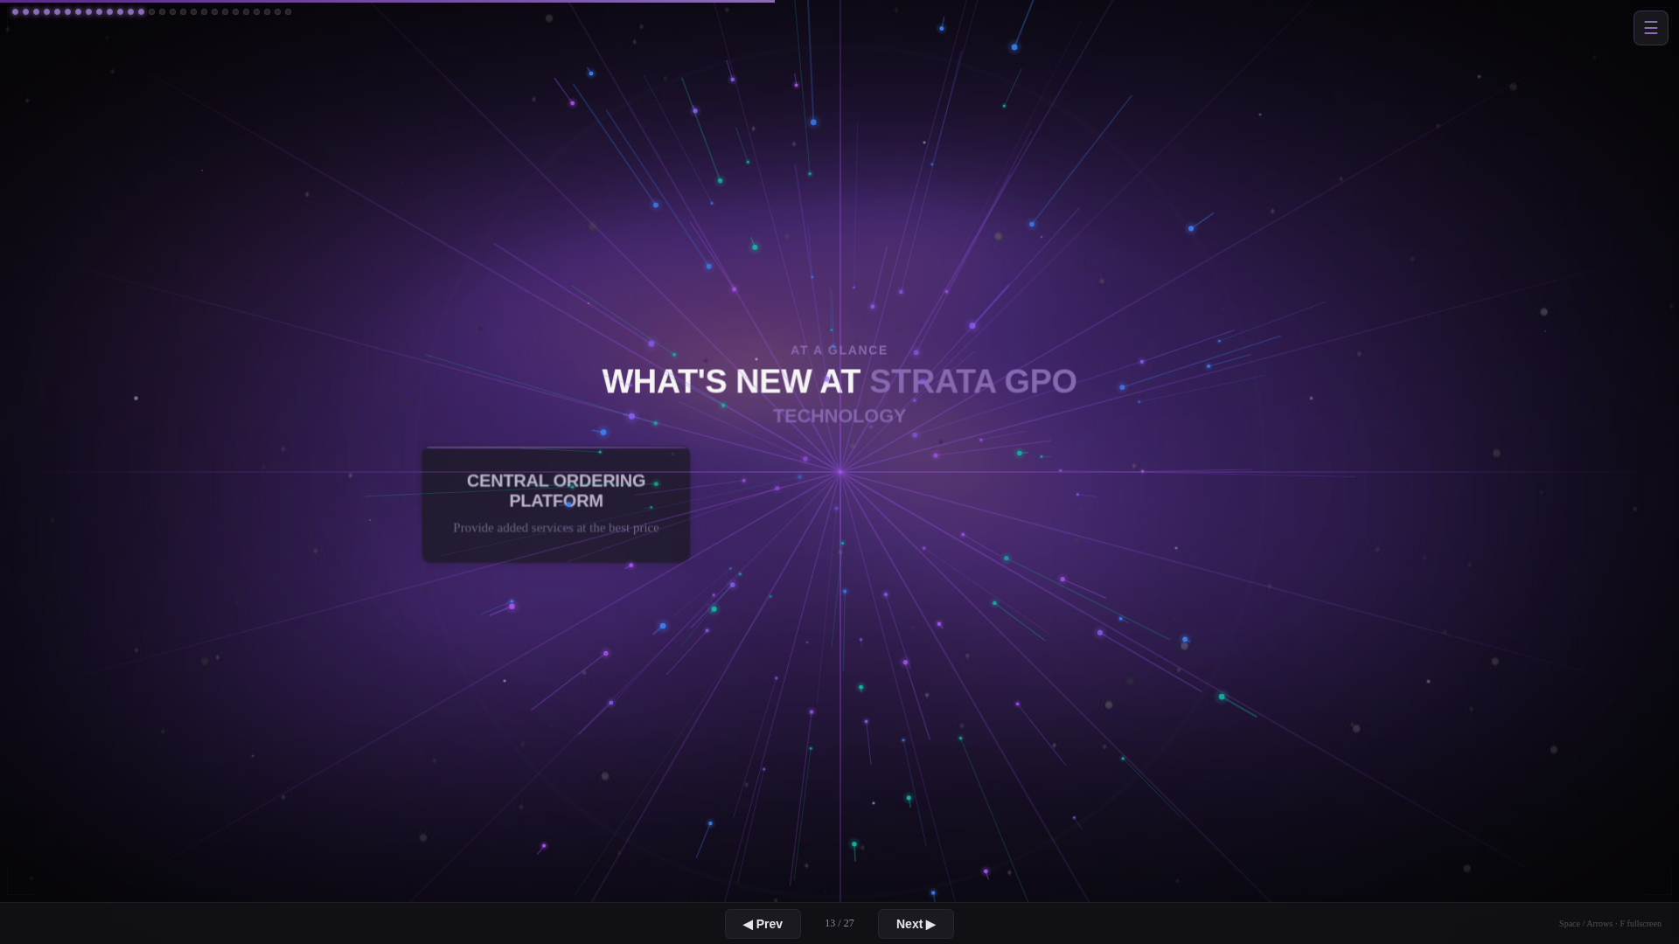
ANDREW MEYER

[ VENDOR A HIGHLIGHTS, PROFIT CALC REVEALS ]
[ WAIT FOR FLOW ANIMATION ]
The system calculates your profit margin on the sale automatically.
33.8% profit margin on Net Net pricing. That’s visibility that changes how you make purchasing decisions.
On the Central Ordering Platform:
• Our goal is simple: bring you more profits.
• Buying group protections are in place. Your programs and community are protected from downside.
We’re about 45 days into this journey and ready to scale.
• Key operational goals: order flow speed and accuracy. Order tracking from placement through shipment to quality control.
• We will leverage AI and the technology we’re building to scale this platform.

SLIDE 18 of 27
WHAT'S NEW: EXPANDED TEAM
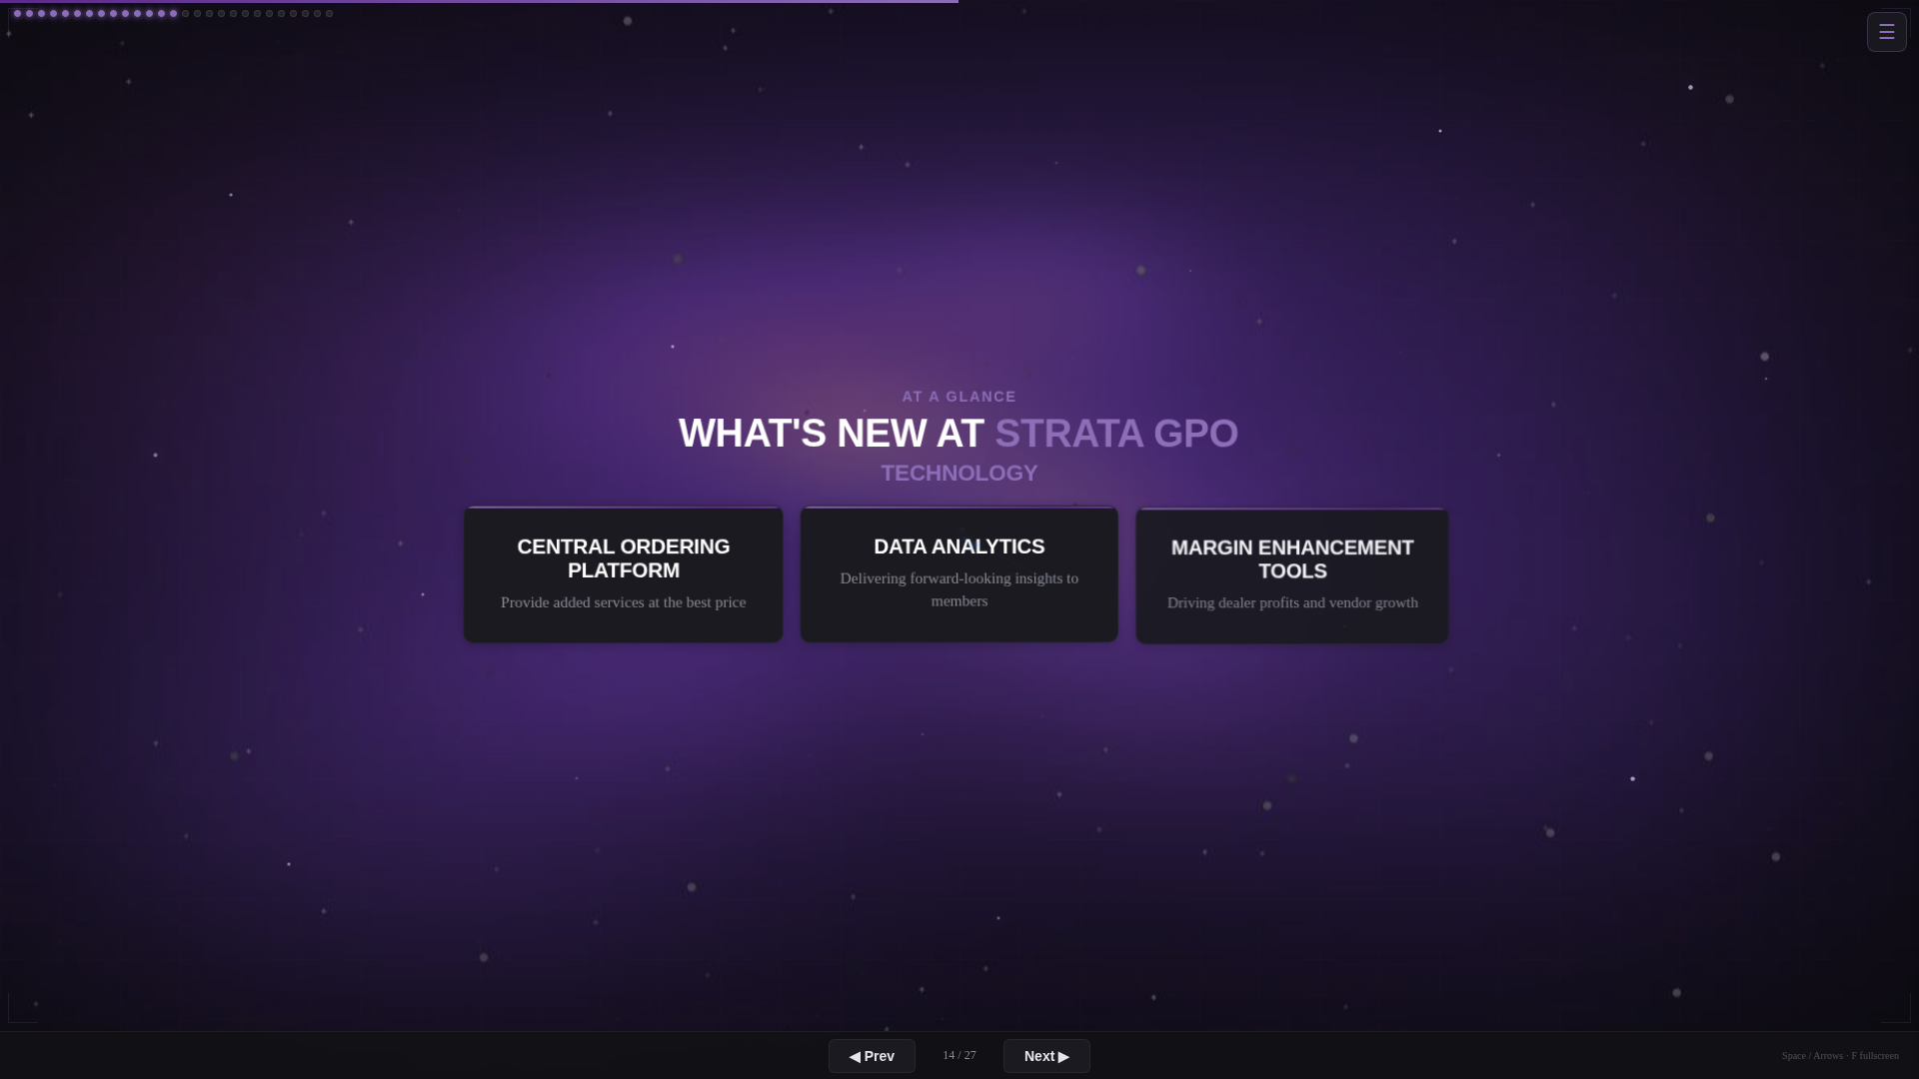

[ Script content to be added ]
Visual / data slide. Speaker notes pending.

SLIDE 19 of 27
WHAT'S NEW: REBRANDING
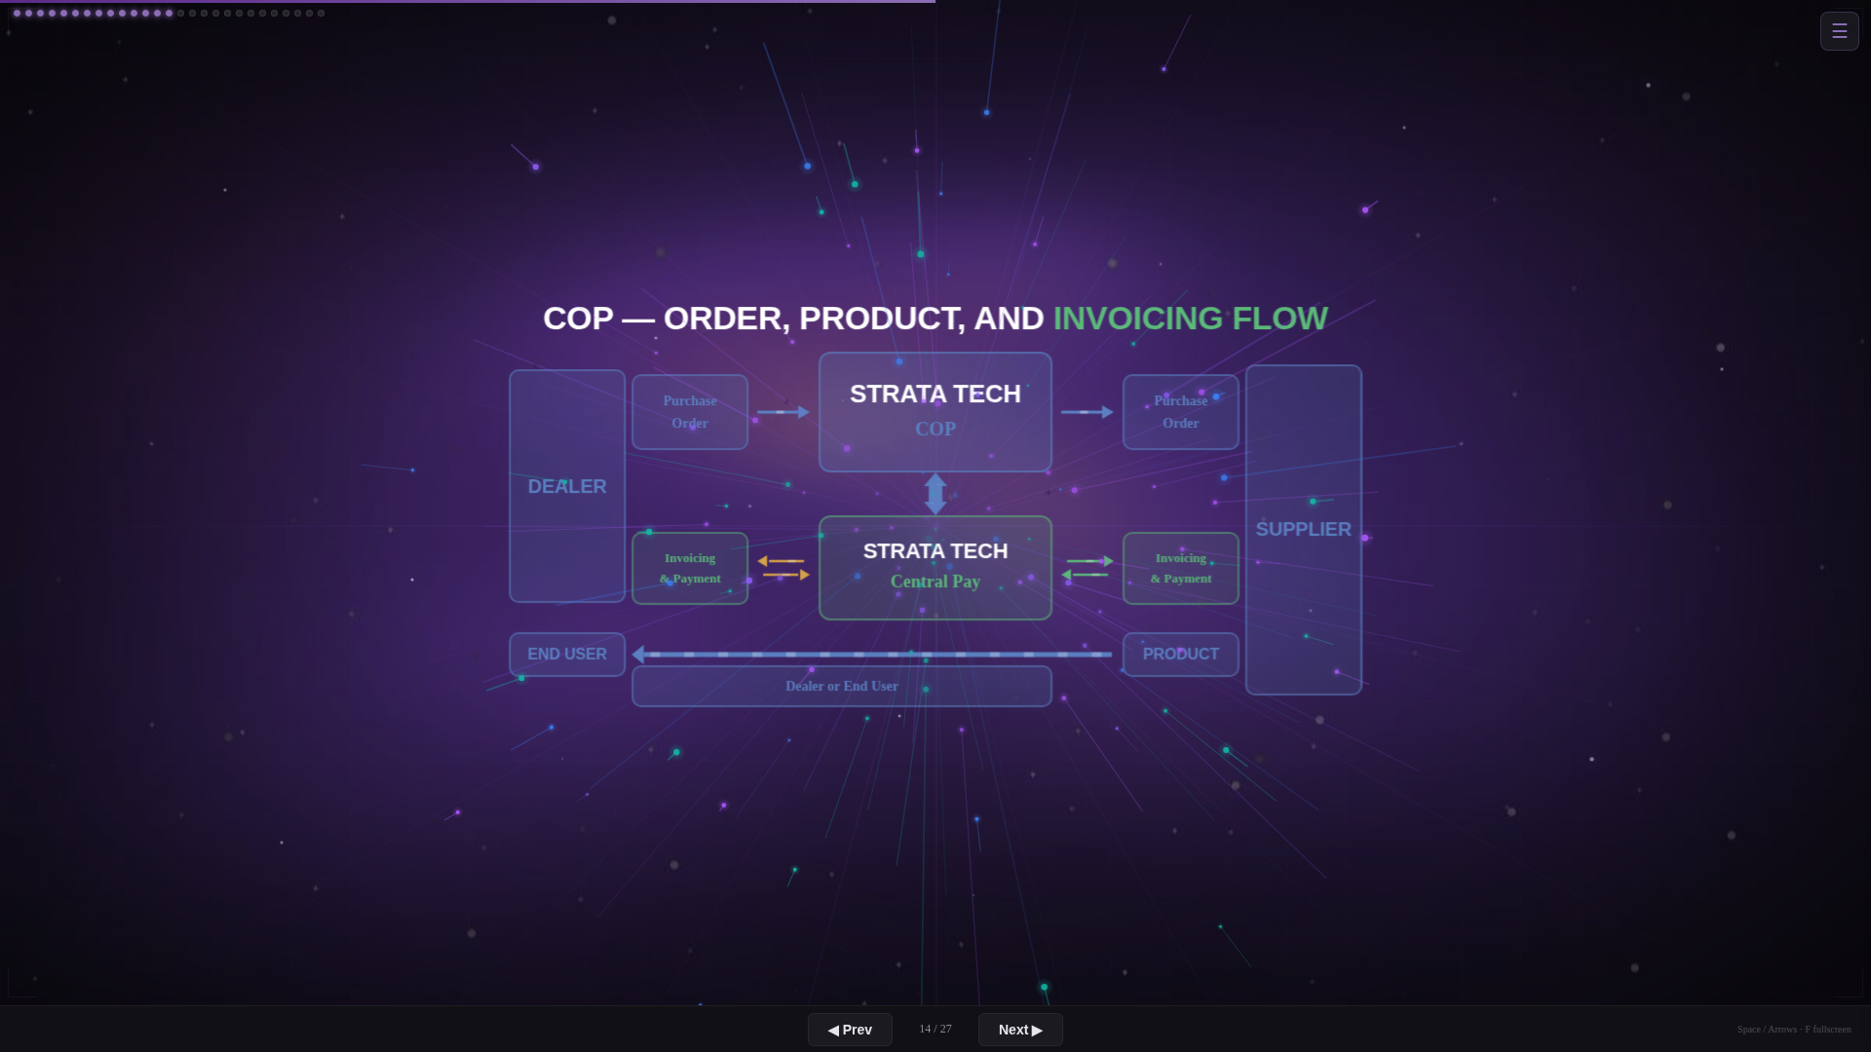

[ Script content to be added ]
Visual / data slide. Speaker notes pending.

SLIDE 20 of 27
MVR CHART
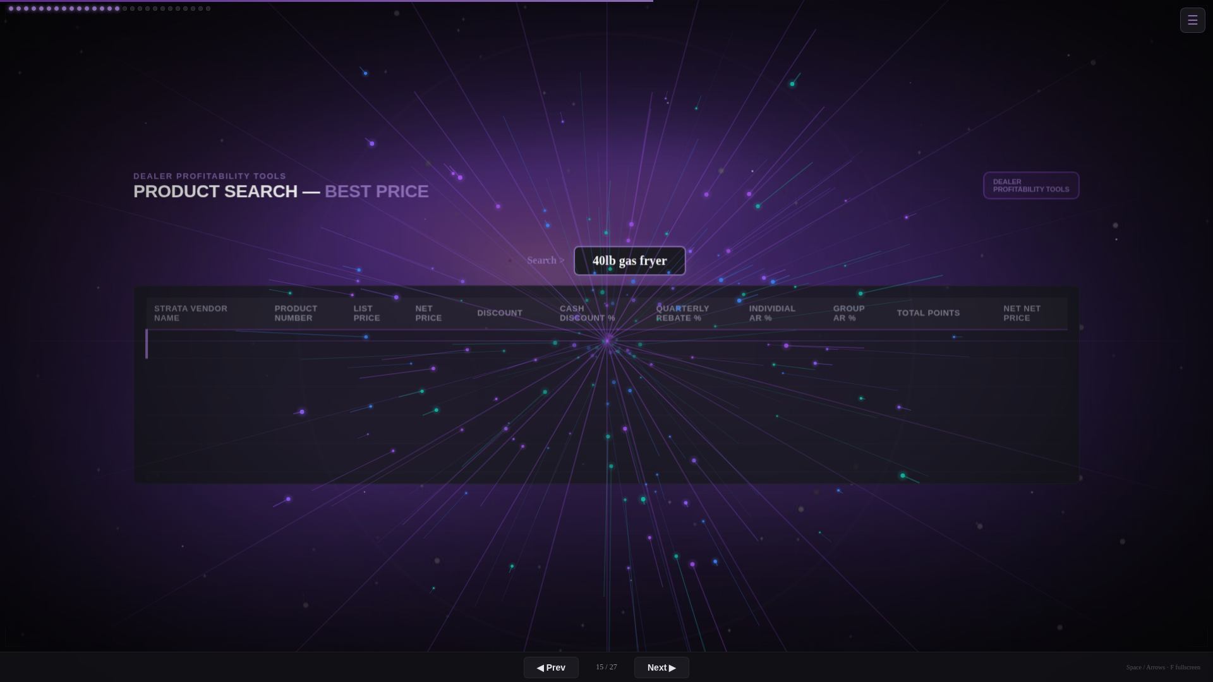

[ Script content to be added ]
Visual / data slide. Speaker notes pending.

SLIDE 21 of 27
PBI RANGES CHART
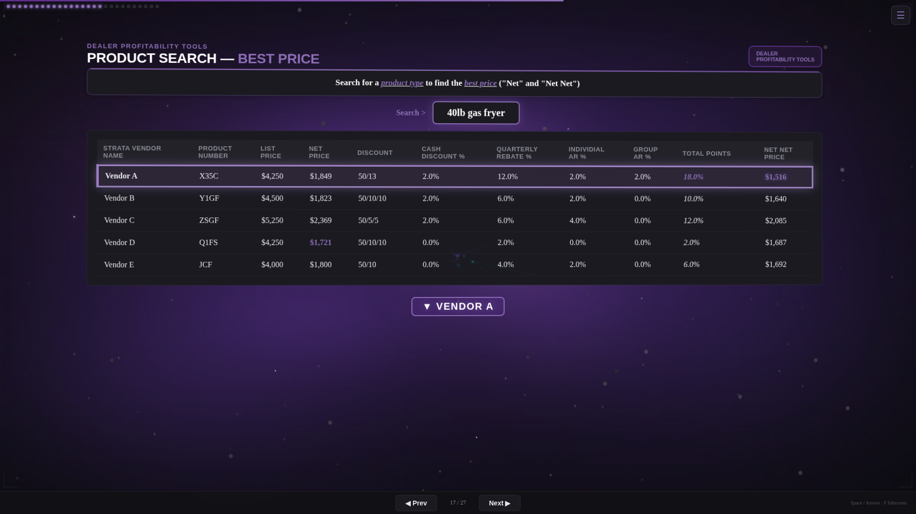

[ Script content to be added ]
Visual / data slide. Speaker notes pending.

SLIDE 22 of 27
PBI REVAMPED
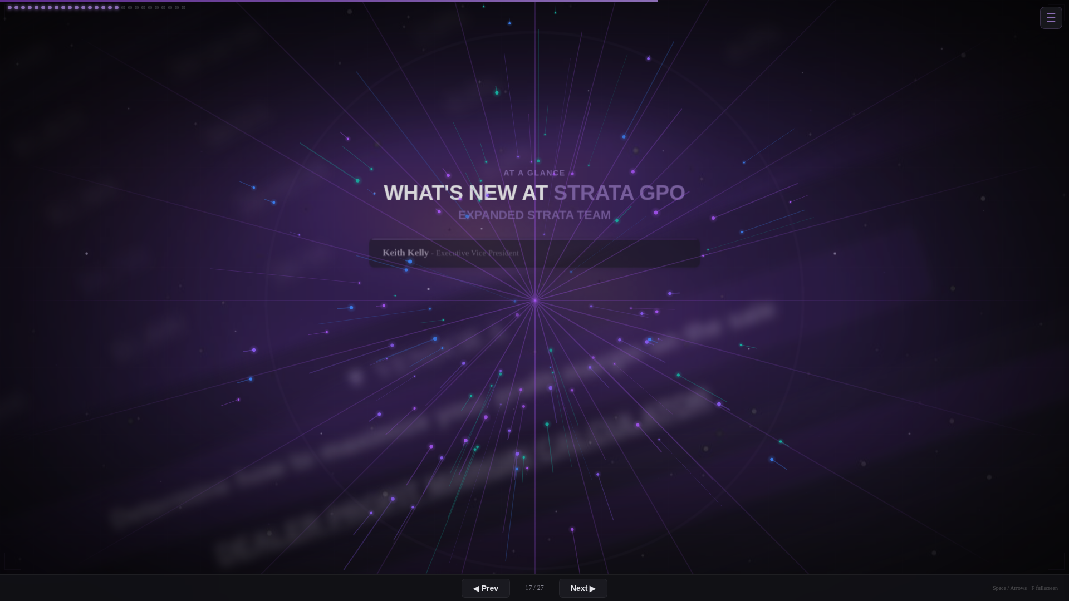
ANDREW MEYER

Let’s talk about the Performance Based Incentive program. We’ve rebranded it, and here’s what changed.
Big change: all members qualify. Segmentation is eliminated.
We’re funding this through multiple sources:
• Minimum volume requirements
• Strata’s management fees
• Performance-based incentive funds
• Vendor marketing allowances
• The Central Ordering Platform
Multiple funding sources means we can grow and expand this program for top members as we scale. More predictability on incentive amounts. More visibility for you.
Tracking is coming soon.
On minimum volume requirements, here’s what’s different:
• All in-group volume counts. If Strata has a contract with a vendor, that volume counts toward your requirement.
• All volume through the Central Ordering Platform counts.
• The program incentivizes growth. Your year-end volume applies back to dollar one.
And we don’t take it away if you fall short.

SLIDE 23 of 27
PBI PAYOUT TREND
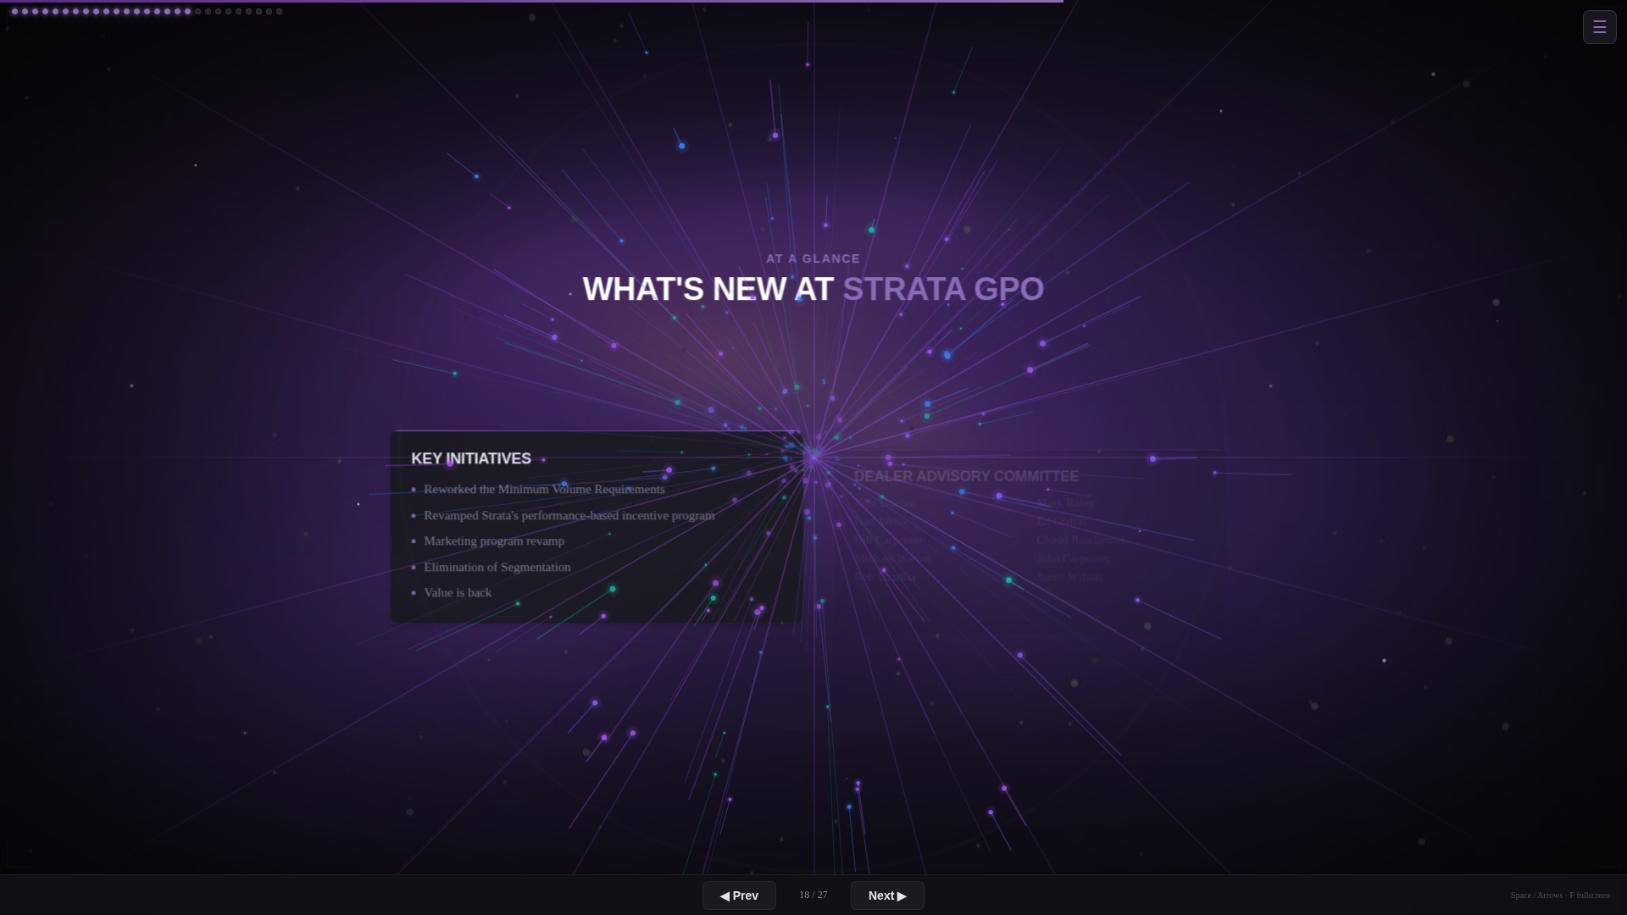

[ Script content to be added ]
Visual / data slide. Speaker notes pending.

SLIDE 24 of 27
PBI FUND SOURCE MIX
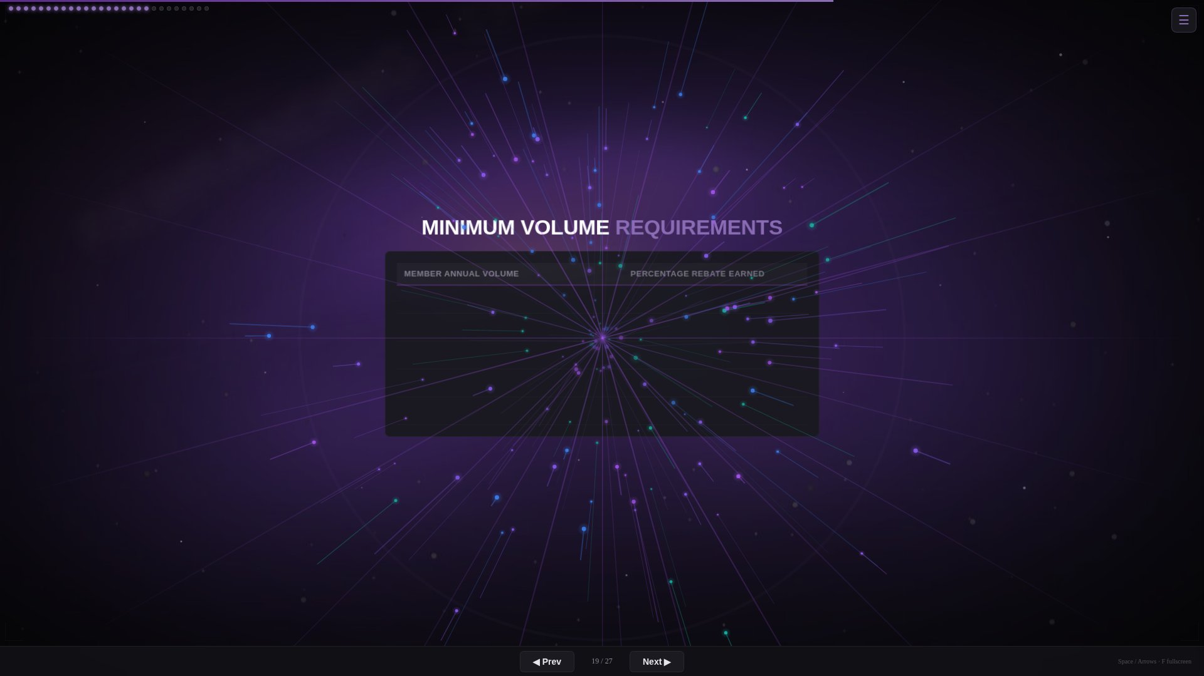

[ Script content to be added ]
Visual / data slide. Speaker notes pending.

SLIDE 25 of 27
VALUE AT TABLES
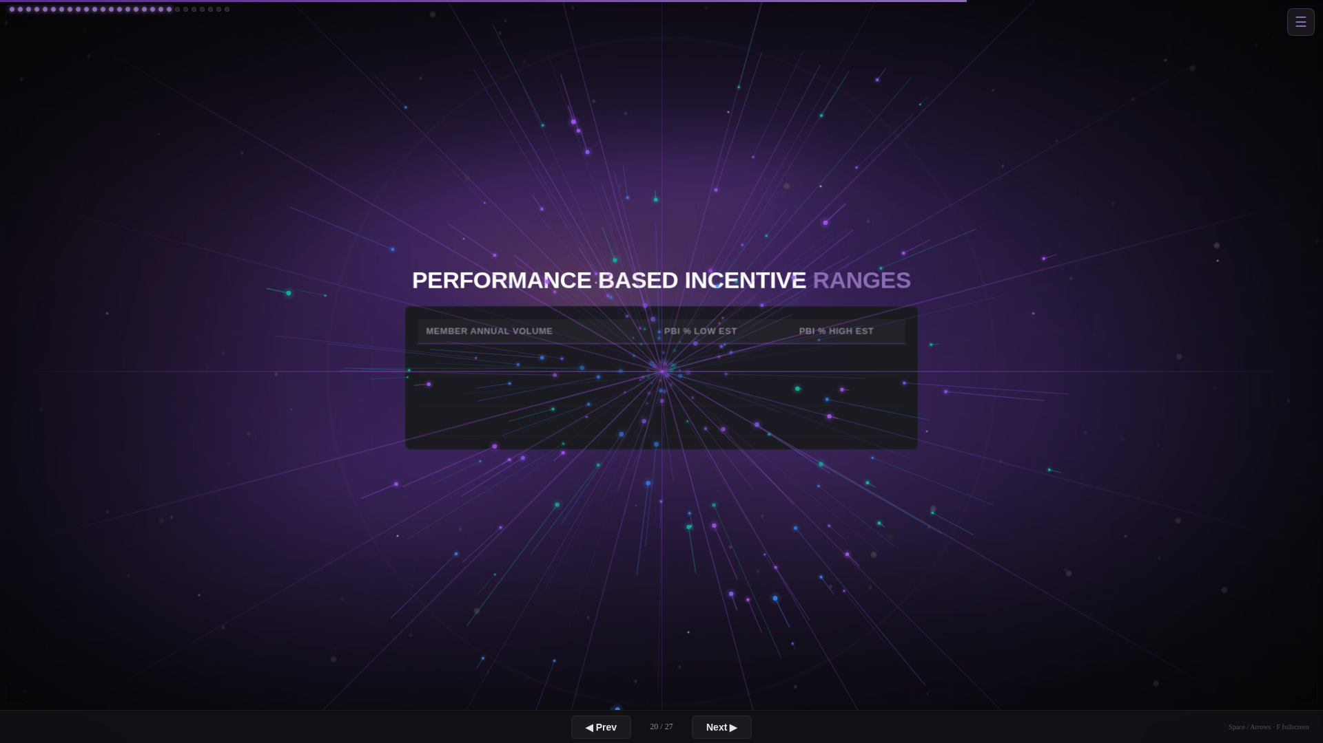

[ Script content to be added ]
Visual / data slide. Speaker notes pending.

SLIDE 26 of 27
NEXT JOB AT HAND
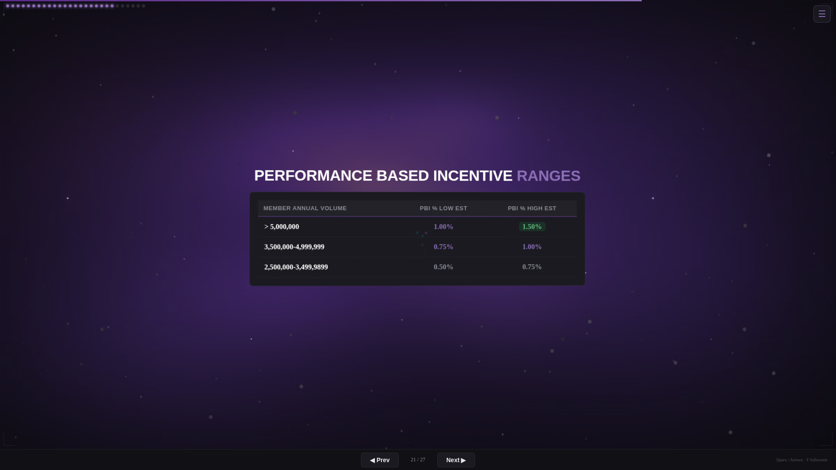

[ Script content to be added ]
Visual / data slide. Speaker notes pending.

SLIDE 27 of 27
Q&A
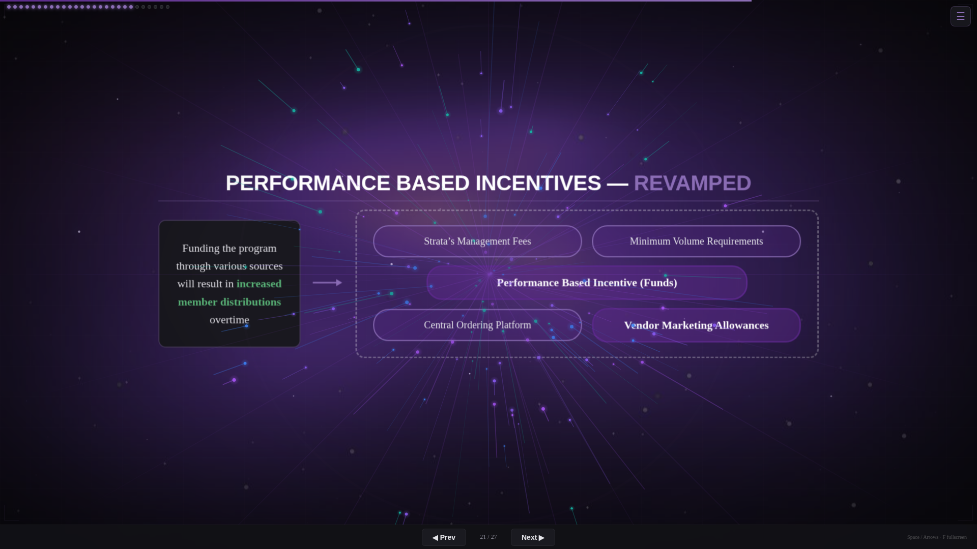
JOHN PERRUCCIO

If there is an order that was given to another dealer then there alone is the opportunity to grow.
Do not focus on the noise around you. There will always be plenty of excuses of how the obstacles were too large or the economy was too bad. Differentiate your business to provide services clients can’t live without.
Plan for your own success and chart that course. Climb the mountain looking up, not backwards.
I have worked with many of the manufacturers here in the room over the years and with all the buying groups. I can assure you that there is no other group that is offering more advanced services through technology than we are here. And no one is developing them faster than we are.
We will keep you out in front and growing through relationships and technology faster than any other group can and will. Our technology is built specifically for our industry and not a canned software from developers that do not know our business. Lean in.
[ PAUSE — OPEN FOR QUESTIONS ]

